

**Vim**

**Presented by**

Prangchompoo Sombat 6607012660078

**Presented to**

ASSISTANT PROFESSOR DR. NATTAPORN UTAKRIT

Fundamental Computer and Networking (070153603)

**Program in Informatics for Digital Economy Faculty of Information Technology Innovation**

## **What is Vim?**

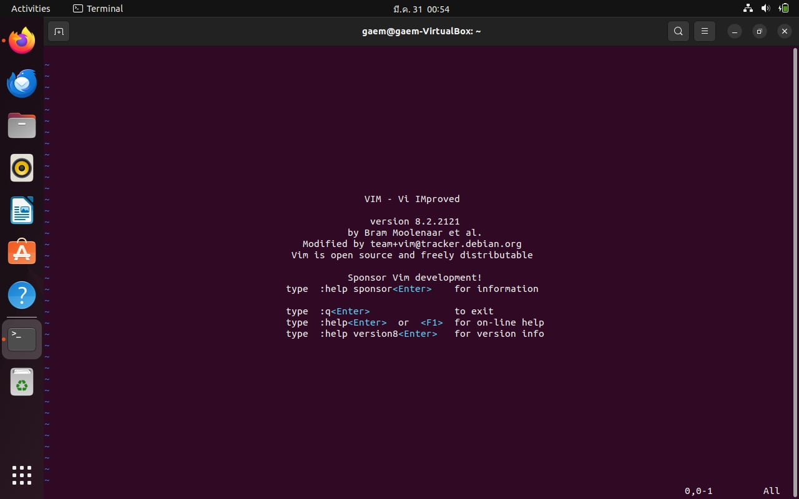

Vim is a text editor for Unix that comes with Linux, BSD, and macOS. It is known to be fast and powerful, partly because it is a small program that can run in a terminal (although it has a graphical interface). It is mainly because it can be managed entirely without menus or a mouse with a keyboard.

**Why install Vim?**

Vim is a powerful text editor popular among developers. It's based on shortcuts, called the Vim language, which can make coding and writing faster and more efficient.

**How to install Vim**

Step 1:Open terminal application.

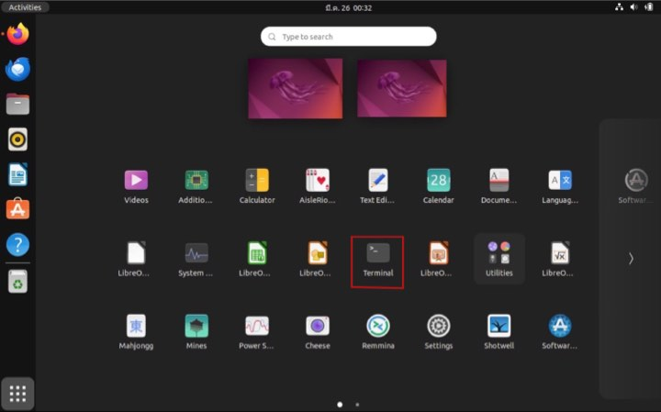

Step 2:Update the package list “ **sudo apt update**”

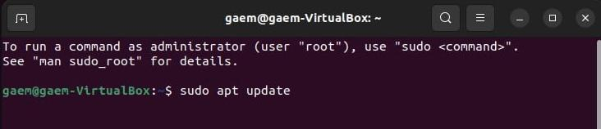

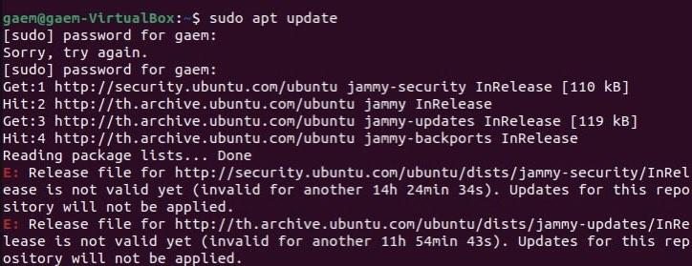

Step3: Install Vim “**sudo apt install vim -y**”

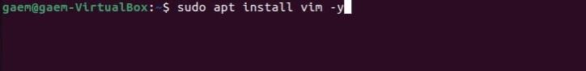

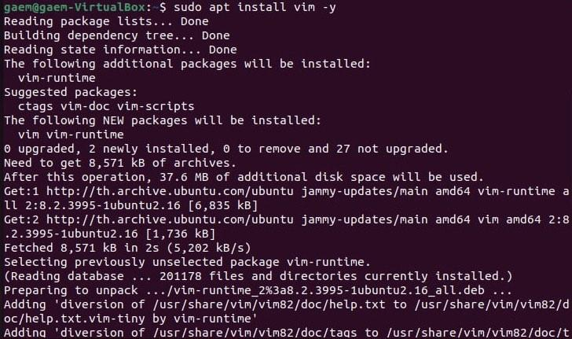

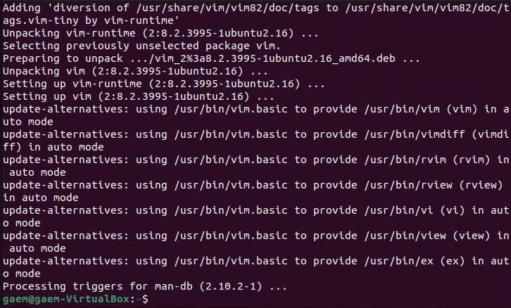

Step4:Verify the installation “**vim --version**”

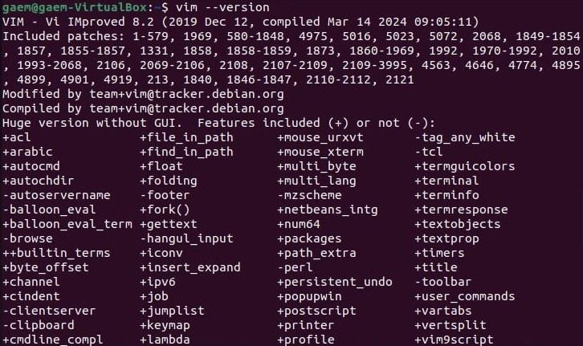

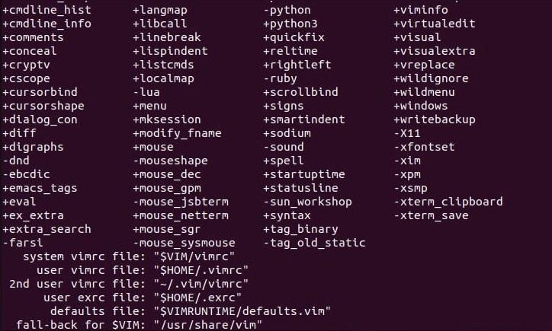

**An Example Project**

**- I use Vim to write keystrokes for vim users. For Beginners to learn the basics of using Vim.**

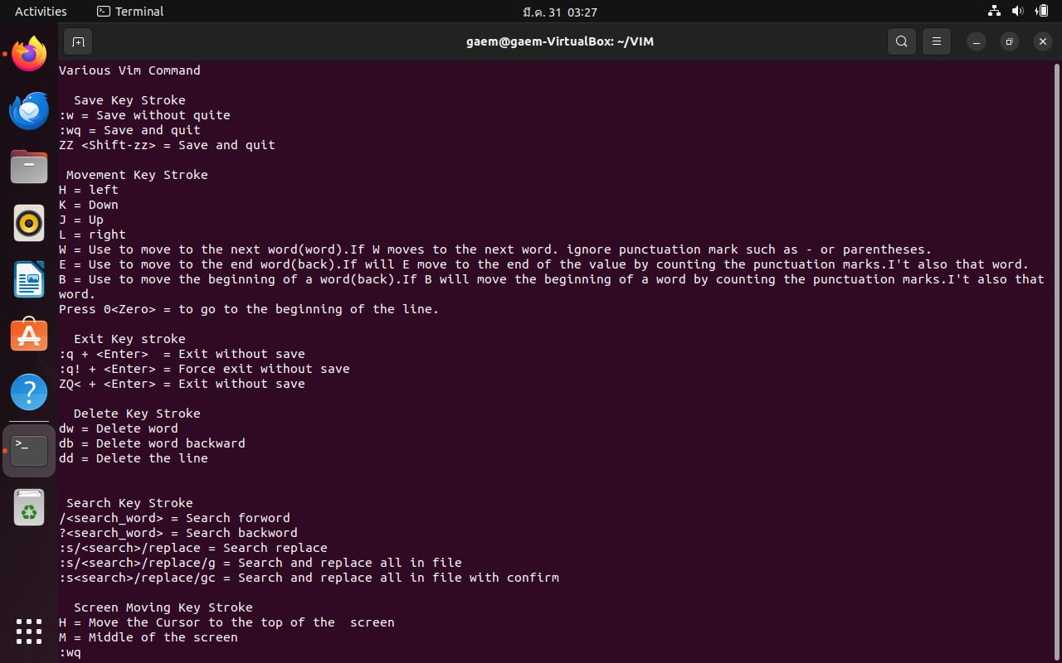

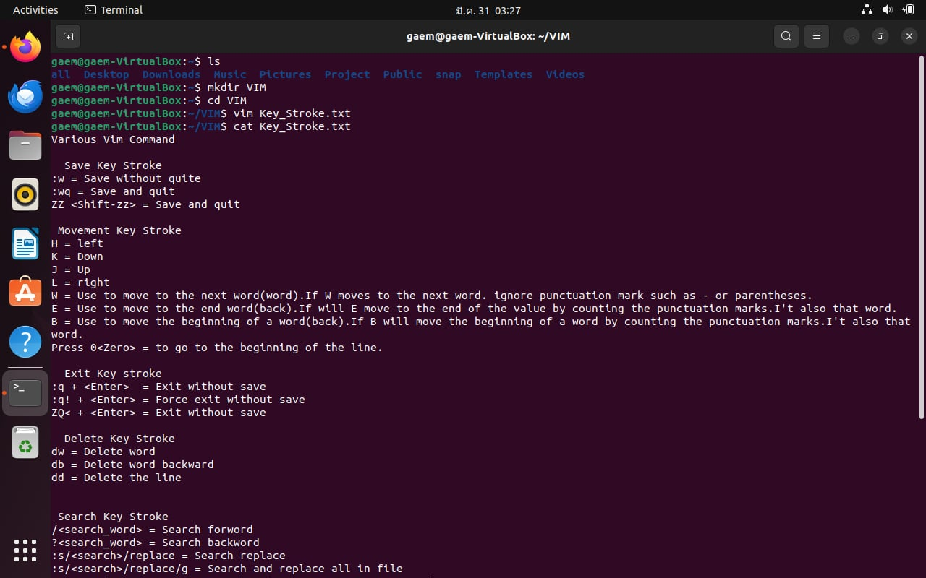

[**https://docs.google.com/document/d/1fh00sPe4xSr8coPvjyML8CxWFdx1754PBzHGj2xJ8Wo/edit?usp=sharing**](https://docs.google.com/document/d/1fh00sPe4xSr8coPvjyML8CxWFdx1754PBzHGj2xJ8Wo/edit?usp=sharing)

**References**

[**https://www.cherryservers.com/blog/install-vim-ubuntu**](https://www.cherryservers.com/blog/install-vim-ubuntu)

[**https://www.loginradius.com/blog/engineering/vim-getting-started/**](https://www.loginradius.com/blog/engineering/vim-getting-started/)

[**https://www.freecodecamp.org/news/vim-language-and-motions-explained/**](https://www.freecodecamp.org/news/vim-language-and-motions-explained/)

## **What is Vim?**

Vim is a text editor for Unix that comes with Linux, BSD, and macOS. It is known to be fast and powerful, partly because it is a small program that can run in a terminal (although it has a graphical interface). It is mainly because it can be managed entirely without menus or a mouse with a keyboard.

(<https://www.loginradius.com/blog/engineering/vim-getting-started/>)

**Why install Vim?**

Vim, short for Vi IMproved, stands out as an exceptionally versatile, powerful, and efficient text editor.